The Wannsee Conference
The conference represents the involvement of the entire German state administration in the genocide, which was implemented by a range of authorities. The 15 participants at the conference were among the elite of the National Socialist regime. Their biographies show that many had completed an academic education and had brilliant careers. Eight held doctorates. Most were from “good middleclass” homes. Some were staunch National Socialists but others had joined the party for opportunistic reasons.
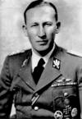
Reinhard Heydrich (1904 - 1942) Head of the Reich Security Main Office. (RSHA) Head of the Security Police and the SD. Acting Reich Protector of Bohemia and Moravia. ^{(Foto: Ullstein Bilderdienst)}
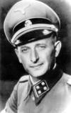

Adolf Eichmann (1906 - 1962) Director of Section IV B 4. Reich Security Main Office (RSHA). (Foto: Bundesarchiv Berlin, Berlin Document Center)

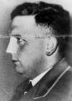

Dr Josef Bühler (1904 - 1948) State Secretary. Government of the Governor General in Cracow. ^{(Foto: IPN Warsaw)}

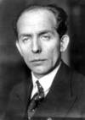
Dr Roland Freisler (1893 - 1945) State Secretary. Reich Ministry of Justice. (Foto: Landesbildstelle Berlin)
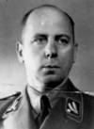

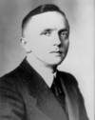
Otto Hofmann (1896 - 1982) Head of the Race and Settlement Main Office (RuSHA). ^{(Foto: Bundesarchiv Berlin}

Dr Gerhard Klopfer (1905 - 1987) Permanent Secretary. Party Chancellery of the NSDAP. (Foto: Bundesarchiv Berlin, Berlin Document Center)

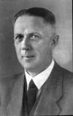
Wilhelm Kritzinger (1890 - 1947) Permanent Secretary. Reich Chancellery. (Foto: Persönlichkeiten der Verwaltung, Stuttgart 1991)
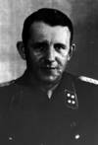
Dr Rudolf Lange (1910 - 1945) Commander of the Security Police and the SD (KdS). (Foto: Bundesarchiv Berlin, Berlin Document Center)
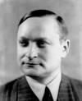
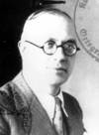
Dr Georg Leibbrandt (1899 - 1982) Permanent Secretary . Reich Ministry for the Occupied Eastern Territories. (Foto: Bundesarchiv Berlin, Berlin Document Center)

Martin Luther (1895 - 1945) Under-Secretary of State. Foreign Office. (Foto: Bundesarchiv Berlin, Berlin Document Center)

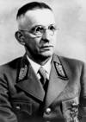
Dr Alfred Meyer (1891 - 1945) State Secretary. Reich Ministry for the Occupied Eastern Territories. (Foto: Bundesarchiv Berlin, Berlin Document Center)

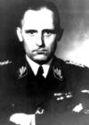
Heinrich Müller (1900 - disappeared 1945) Head of Department IV Gestapo. Reich Security Main Office. (Foto: Bundesarchiv Berlin, Berlin Document Center)
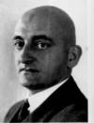
Erich Neumann (1892 - 1951) State Secretary. Office of the Plenipotentiary for the Fourth Year Plan. ^{(Foto: Ullstein Bilderdienst)}

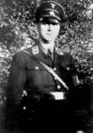
Dr Eberhard Schöngarth (1903 - 1946) Commander in Chief of the Security Police and the SD (BdS). ^{(Foto: Mollo Archives)}
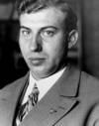
Dr Wilhelm Stuckart (1902 - 1953) State Secretary. Reich Ministry of the Interior. ^{(Foto: Ullstein Bilderdienst)}

