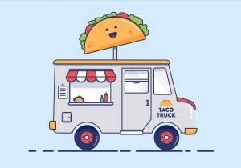
The Bureaucracy of Taco Trucks

Taking a Closer Look at How the Federal Bureaucracy Governs Your Taco!

1789 the State Department had 9 employees, the War Department had 2, and the Treasury Department had 39. Today, the State Department employs about 32,000 civilians, the Defense Department about 760,000, and the Treasury Department about 108,000. The federal bureaucracy today boasts 15 Cabinet departments and dozens of agencies, regulatory commissions, and government corporations, with a civilian workforce of more than 2.8 million. The bureaucratic behemoth exercises power and influence over virtually every facet of the nation’s social and economic life. In the view of many observers, the power, reach, and independence of the federal bureaucracy demand that it be viewed as a fourth branch of government.

Directions: Your task is to take each component of a taco truck and, using the links below, research the federal agencies and departments that would regulate it in some way. Use the chart on the reverse side to explain how each component of the taco truck is regulated by the agency and/or department.

Internet Resources:
The links below will assist you in determining how each federal agency and/or department regulates each taco truck component:

- Food Truck Regulations
  - https://foodtruckr.com/2017/03/street-food-rules-and-regulations-food-truckers-should-know-about/
- Taco Shells
  - https://www.ams.usda.gov/sites/default/files/media/CID%20Tortillas%2C%20Tortilla%20Chips%2C%20Taco%20Shells%2C%20and%20Tostada%20Shells.pdf
- Taco Meat
  - http://www.newser.com/story/186139/taco-bell-reveals-exactly-whats-in-its-mystery-meat.html
  - https://www.fsis.usda.gov/wps/portal/fsis/topics/food-safety-education/get-answers/food-safety-fact-sheets/production-and-inspection/inspection-and-grading-of-meat-and-poultry-what-are-the-differences_/inspection-and-grading-differences
- Cheese
  - https://www.ams.usda.gov/grades-standards/cheddar-cheese-grades-and-standards
- Tomato
  - https://www.ams.usda.gov/grades-standards/tomato-grades-and-standards
- Lettuce
  - https://www.fda.gov/downloads/Food/GuidanceRegulation/UCM169008.pdf
- Sour Cream
  - https://www.gpo.gov/fdsys/pkg/CFR-2006-title21-vol2/pdf/CFR-2006-title21-vol2-sec131-160.pdf
- Beans
  - http://www.registrarcorp.com/fda-fce-sample/Refried_Beans?lang=en
- Avocado
  - http://www.thepacker.com/fruit-vegetable-news/USDA-eases-avocado-regulations-126125793.html

Ingredients
Food Truck Regulations | Department/Organization: ___________________________________________________  Regulatory Oversight:
Taco Shells | Department/Organization: ___________________________________________________  Regulatory Oversight:
Taco Meat | Department/Organization: ___________________________________________________  Regulatory Oversight:
Cheese | Department/Organization: ___________________________________________________  Regulatory Oversight:
Tomato | Department/Organization: ___________________________________________________  Regulatory Oversight:
Lettuce  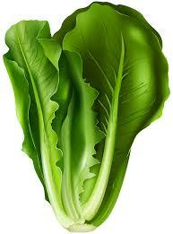 | Department/Organization: ___________________________________________________  Regulatory Oversight:
Sour Cream | Department/Organization: ___________________________________________________  Regulatory Oversight:
Beans  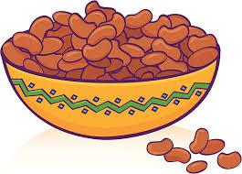 | Department/Organization: ___________________________________________________  Regulatory Oversight:
Avocado  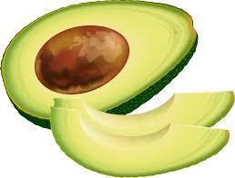 | Department/Organization: ___________________________________________________  Regulatory Oversight:

Questions to Answer
- What generalizations can you make about the “bureaucracy of a taco truck” i.e. how involved are federal agencies and departments in the tacos that you eat?

- What are the advantages and disadvantages to consumers of tacos (like you) of federal rules and regulations? Advantages and disadvantages for taco truck businesses?
Consumers

Advantages | Disadvantages

Taco Truck Businesses

Advantages | Disadvantages

- Based on what you learned from this activity about the bureaucracy of pizza, would you go into the pizza/taco business? Why or why not?

